ARIA Testify Live Monitor
Does your web page have an ARIA-live region and will it be announced by a screen reader? Do you want to test it without actually using a screen reader?
Steve Faulkner has created a free, open source Windows app called ARIA Testify Live Monitor, which records accessibility announcements exposed through Windows UI Automation. If you've ever used JAWS Inspect, it reminds me of it. It listens for:
- UIA LiveRegionChanged events, normally used for aria-live and roles with implicit live-region semantics;
- UIA Notification events, which supporting Windows browsers can use for ariaNotify();
- recent global keyboard and pointer input, used as a fallback trigger correlation.
An optional Chrome or Microsoft Edge companion enriches a captured platform event with the exact browser-side method, DOM source, selector, page URL, initiating DOM event, and trigger element. Browser observations do not create list entries on their own: a matching UIA event is required.
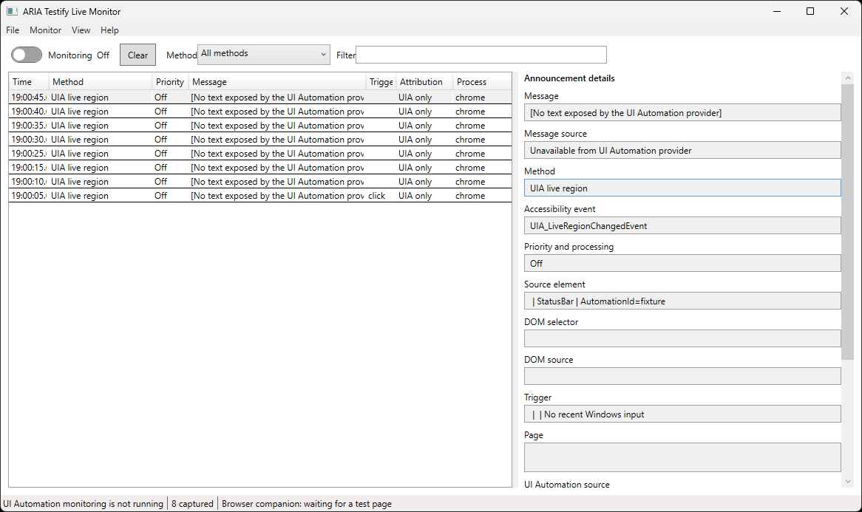
Figure 1: Example read out from ARIA Testify Live Monitor

What each row contains
- timestamp;
- exposed message, or correlated added/updated DOM text when the UI Automation provider exposes no message;
- message source, identifying whether the displayed text came from UI Automation or the browser companion;
- UIA event type;
- method, such as explicit aria-live, implicit role=status, HTML <output>, or Element.ariaNotify();
- politeness or notification priority when available;
- UIA source element and process;
- DOM source and selector when browser enrichment succeeds;
- initiating DOM event and target when one was recently observed;
- UIA notification kind, processing mode, and activity ID;
- attribution confidence and limitations.
The list can be filtered and exported to CSV or JSON.
Download here: https://github.com/stevefaulkner/ARIA-testify#aria-testify-live-monitor
The downloadable file includes a test HTML file that provides examples of
- Explicit aria-live
- Implicit ARIA live roles
- HTML <output>
- ariaNotify()
- Programmatic trigger
- Implicit live setting off
Deque also has a live region playground page, which you can use to test it out:
https://dequeuniversity.com/library/aria/liveregion-playground

